**STUDENT DATABASE MANAGEMENT SYSTEM**

**IP PROJECT**

**2015-2016**

**MADE BY-**

**Shivani Bhandari**

**Xii – C**

**12306**

**CERTIFICATE**

**This is to certify that SHIVANI BHANDARI of class XII –C has carried out the project work as per the guidelines by Ms.Meeta Pajwani. They had prepared “STUDENT DATABASE MANAGEMENT SYSTEM” project under the supervision of Ms.Meeta Pajwani during the academic year 2015-16 in K.D.AmbaniVidyamandir.**

**INTERNAL EXAMINER EXTERNAL EXAMINER**

**(Ms. Meeta Pajwani)**

**PRINCIPAL**

**index**

|  |  |
| --- | --- |
| **S.No** | **Topic** |
| 1. | Preface |
| 2. | Acknowledgement |
| 3. | Hardware / Software |
| 4. | Specification |
| 5. | Introduction |
| 6. | Front End and Back End |
| 7. | Bibliography |

Preface

Since the development of computers, they have been used in a large number of applications of different conventions. They are used to carry out complex calculations, storing bulk data, etc.

The inherent capability of computers to store large amount of data, retrieve data whenever needed and analyzing the data makes them a very important companion in the success of any company. They have become an important part of today’s industries because of their capabilities to automate the tedious tasks in a more efficient and effective manner.

The advancement in the field of information Technology has raised the need for the trained computer professionals.

Project designing in Informatics Practices is a part of CBSE syllabus in class XII. It helps students for software exposure so as to gain control over programming languages. Such Project making plays a vital role to implement theoretical concepts to enhance their practical knowledge and make them aware about the role situations of the software application.

Acknowledgement

We would like to express our sincere thanks and gratitude to our Principal and our IP teacher Ms.Meeta Pajwani for her constant guidance and valuable help in completing this project.

In all, the project has been challenging and exhilarating experience in terms of analyzing and designing a full -fledged “Student Database Management System”.

Yours faithfully,

Shivani Bhandari

Hardware Specifications

|  |  |  |
| --- | --- | --- |
| Sno. | Components | Description |
| 1. | System | IBM |
| 2. | Processor | Intel (R) Pentium (R) D CPU |
| 3. | Main Memory(RAM) | 2GB |
| 4. | Hard disk | 300GB |

Software specifications

|  |  |  |
| --- | --- | --- |
| S.no | Software Used | Description |
| 1. | Net beans IDE 6.9.1 | Used for Project  Development for Frontend programming |
| 2. | MYSQL Server 5.1 | Used for Project  Development for Backend programming |
| 3. | Microsoft Office 2007 | For documentation |

Introduction

The NetBeans IDE is an award-winning integrated development environment available for Windows, Mac, Linux etc.The NetBeans project consists of an [open-source IDE](http://netbeans.org/features/index.html) and an [application platform](http://netbeans.org/features/platform/index.html) that enable developers to rapidly create web, enterprise, desktop, and mobile applications using the Java platform, as well as JavaFX, PHP, JavaScript and C/C++.

MySQL is the world's most used open source [relational database management system](http://en.wikipedia.org/wiki/Relational_database_management_system) (RDBMS) .The [SQL](http://en.wikipedia.org/wiki/SQL) phrase stands for Structured Query Language.

The MySQL development project has made its [source code](http://en.wikipedia.org/wiki/Source_code) available under the terms of the [GNU General Public License](http://en.wikipedia.org/wiki/GNU_General_Public_License), as well as under a variety of [proprietary](http://en.wikipedia.org/wiki/Proprietary_software) agreements. MySQL is now owned by [Oracle Corporation](http://en.wikipedia.org/wiki/Oracle_Corporation).

MySQL is an open source database management system and is used in some of the most frequently visited websites on the Internet, [Nokia.com](http://en.wikipedia.org/wiki/Nokia), [YouTube](http://en.wikipedia.org/wiki/YouTube) and as previously mentioned, Wikipedia, Google, Facebook and Twitter.

In this Project Netbeans 6.9.1 is used as Frontend and MySQL is used as Backend.

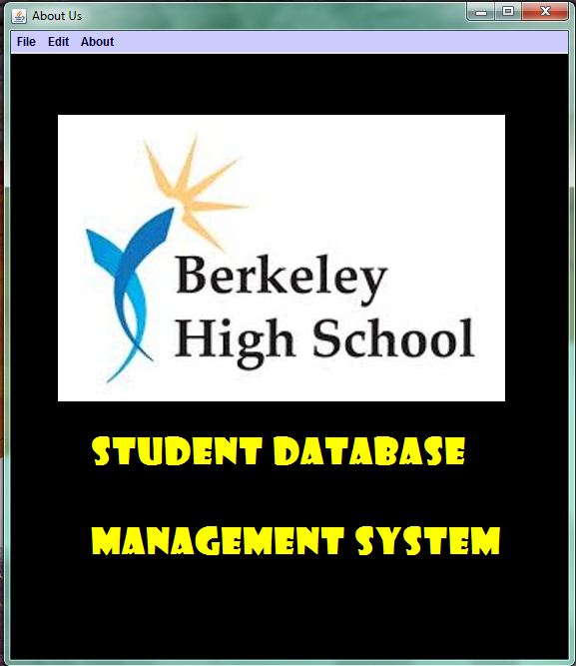

**//Code for Menubar**

private void jMenuItem1ActionPerformed(java.awt.event.ActionEvent evt) {

new main().setVisible(true);

this.setVisible(false);

}

private void jMenuItem2ActionPerformed(java.awt.event.ActionEvent evt) {

new byname().setVisible(true);

this.setVisible(false);

}

private void jMenuItem7ActionPerformed(java.awt.event.ActionEvent evt) {

new byclass().setVisible(true);

this.setVisible(false);

}

private void jMenuItem9ActionPerformed(java.awt.event.ActionEvent evt) {

new byadmno().setVisible(true);

this.setVisible(false);

}

private void jMenuItem3ActionPerformed(java.awt.event.ActionEvent evt) {

System.exit(0);

}

private void jMenu1ActionPerformed(java.awt.event.ActionEvent evt) {

new main().setVisible(true);

this.setVisible(false);

}

private void jMenuItem4ActionPerformed(java.awt.event.ActionEvent evt) {

new edit().setVisible(true);

this.setVisible(false);

}

private void jMenuItem8ActionPerformed(java.awt.event.ActionEvent evt) {

new newsession().setVisible(true);

this.setVisible(false);

}

private void jMenuItem5ActionPerformed(java.awt.event.ActionEvent evt) {

new delete().setVisible(true);

this.setVisible(false);

}

private void jMenu3MouseClicked(java.awt.event.MouseEvent evt) {

new about().setVisible(true);

this.setVisible(false); }

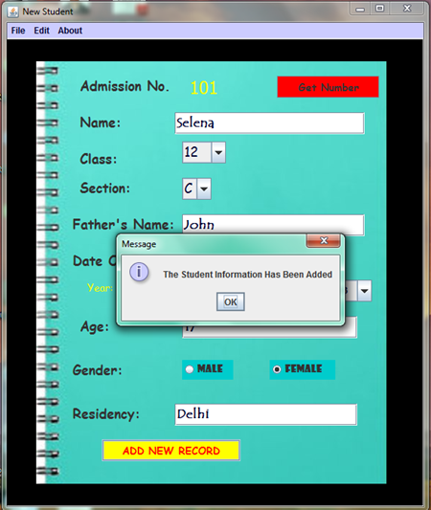

import java.sql.DriverManager;

import java.sql.ResultSet;

import javax.swing.DefaultComboBoxModel;

import javax.swing.JOptionPane;

public class main extends javax.swing.JFrame {

public main() {

initComponents();

setTitle("New Student");

}

**//Code for Get Number Button**

private void jButton2ActionPerformed(java.awt.event.ActionEvent evt) {

String Admno = " ";

int adm = 0;

try {

Class.forName("java.sql.DriverManager");

java.sql.Connection con = DriverManager.getConnection("jdbc:mysql://localhost:3306/studentdatabase", "root", "admin");

java.sql.Statement stmt = con.createStatement();

String Query = "Select max(Admno) from info;";

ResultSet rs = stmt.executeQuery(Query);

while (rs.next()) {

Admno = rs.getString("max(Admno)");

if(Admno.isEmpty())

{

ado.setText("101");

}

else {

adm = Integer.parseInt(Admno);

ado.setText("" + (adm + 1));

} }

} catch (Exception e) {

JOptionPane.showMessageDialog(this, e.getMessage());

} }

**//Code for Add New Record**

private void jButton1ActionPerformed(java.awt.event.ActionEvent evt) {

String day = (String) Day.getSelectedItem();

String month = (String) Month.getSelectedItem();

String year = (String) Year.getSelectedItem();

String date = year + "-" + month + "-" + day;

System.out.println(date);

int admno = Integer.parseInt(ado.getText());

String name = x.getText();

int clas = Integer.parseInt((String) c.getSelectedItem());

String section = (String) s.getSelectedItem();

String father = f.getText();

int age = Integer.parseInt(a.getText());

String residency = r.getText();

String gender = "";

String path = "C:\\\\Users\\\\compaq\\\\Desktop\\\\studentdatabase\\\\src\\\\studentdatabase\\\\"+ admno+".jpg";

System.out.println(path);

if (jRadioButton1.isSelected()) {

gender = "M";

} else if (jRadioButton2.isSelected()) {

gender = "F";

} else if (jRadioButton1.isSelected() == false || jRadioButton2.isSelected() == false) {

JOptionPane.showMessageDialog(this, "Please Select Gender");

}

try {

Class.forName("java.sql.DriverManager");

java.sql.Connection con = DriverManager.getConnection("jdbc:mysql://localhost:3306/studentdatabase", "root", "admin");

java.sql.Statement stmt = con.createStatement();

String Query = "Insert into info values('" + admno + "','" + name + "','" + clas + "','" + section + "','" + father + "','" + date + "','" + age + "','" + gender + "','" + residency + "','" + path + "');";

stmt.executeUpdate(Query);

JOptionPane.showMessageDialog(this, "The Student Information Has Been Added");

ado.setText("");

x.setText("");

c.setSelectedIndex(0);

s.setSelectedIndex(0);

f.setText("");

a.setText("");

r.setText("");

Month.setSelectedIndex(0);

Day.setSelectedIndex(0);

Year.setSelectedIndex(0);

}

catch (Exception e) {

JOptionPane.showMessageDialog(this, e.getMessage());

} }

**//Code for Gender Radio button**

private void MonthActionPerformed(java.awt.event.ActionEvent evt) {

DefaultComboBoxModel db=(DefaultComboBoxModel) Day.getModel();

String mon=(String)Month.getSelectedItem();

db.removeAllElements();

if(mon.equals("01")||mon.equals("03")||mon.equals("05")||mon.equals("07")||mon.equals("08")||mon.equals("10")||mon.equals("12")){

db.addElement("01");

db.addElement("02");

db.addElement("03");

db.addElement("04");

db.addElement("05");

db.addElement("06");

db.addElement("07");

db.addElement("08");

db.addElement("09");

db.addElement("10");

db.addElement("11");

db.addElement("12");

db.addElement("13");

db.addElement("14");

db.addElement("15");

db.addElement("16");

db.addElement("17");

db.addElement("18");

db.addElement("19");

db.addElement("20");

db.addElement("21");

db.addElement("22");

db.addElement("23");

db.addElement("24");

db.addElement("25");

db.addElement("26");

db.addElement("27");

db.addElement("28");

db.addElement("29");

db.addElement("30");

db.addElement("31"); }

if(mon.equals("04")||mon.equals("06")||mon.equals("09")||mon.equals("11")){

db.addElement("01");

db.addElement("02");

db.addElement("03");

db.addElement("04");

db.addElement("05");

db.addElement("06");

db.addElement("07");

db.addElement("08");

db.addElement("09");

db.addElement("10");

db.addElement("11");

db.addElement("12");

db.addElement("13");

db.addElement("14");

db.addElement("15");

db.addElement("16");

db.addElement("17");

db.addElement("18");

db.addElement("19");

db.addElement("20");

db.addElement("21");

db.addElement("22");

db.addElement("23");

db.addElement("24");

db.addElement("25");

db.addElement("26");

db.addElement("27");

db.addElement("28");

db.addElement("29");

db.addElement("30");

}

if(mon.equals("02")){

db.addElement("01");

db.addElement("02");

db.addElement("03");

db.addElement("04");

db.addElement("05");

db.addElement("06");

db.addElement("07");

db.addElement("08");

db.addElement("09");

db.addElement("10");

db.addElement("11");

db.addElement("12");

db.addElement("13");

db.addElement("14");

db.addElement("15");

db.addElement("16");

db.addElement("17");

db.addElement("18");

db.addElement("19");

db.addElement("20");

db.addElement("21");

db.addElement("22");

db.addElement("23");

db.addElement("24");

db.addElement("25");

db.addElement("26");

db.addElement("27");

db.addElement("28"); } }

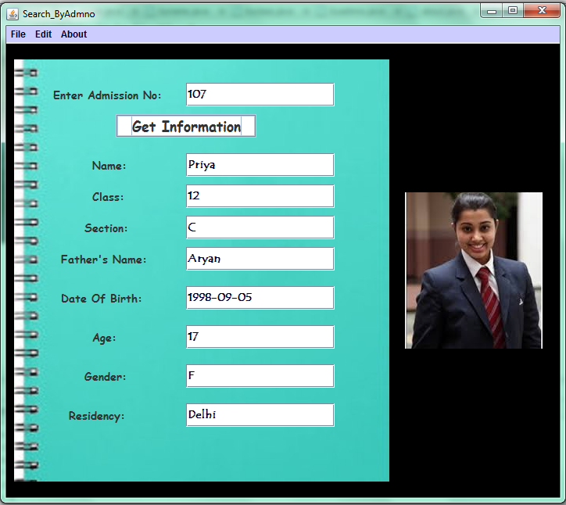

import java.sql.*;

import javax.swing.ImageIcon;

import javax.swing.JOptionPane;

public class byadmno extends javax.swing.JFrame {

private Object jLabel3;

public byadmno()

{

initComponents();

setTitle("Search_ByAdmno");

}

**// Code for Get Information**

private void jButton3ActionPerformed(java.awt.event.ActionEvent evt) {

String Admno = adm.getText();

String Path = "";

int clas, age;String resno="";

String section, date, fname, gender,name;

try

{

Class.forName("java.sql.DriverManager");

Connection con = (Connection)DriverManager.getConnection("jdbc:mysql://localhost:3306/studentdatabase", "root", "admin");

Statement stmt = (Statement)con.createStatement();

String Query = "Select * from info where admno ='" + Admno + "';";

ResultSet rs = stmt.executeQuery(Query);

while (rs.next())

{

name = rs.getString("name");

clas = Integer.parseInt(rs.getString("Clas"));

age = Integer.parseInt(rs.getString("Age"));

resno = rs.getString("Residency");

section = rs.getString("Section");

date = rs.getString("date");

fname = rs.getString("Father");

gender = rs.getString("Gender");

Path = rs.getString("Path");

System.out.print(Path);

jLabel4.setIcon(new ImageIcon(Path));

n2.setText(name);

c2.setText("" + clas);

s2.setText(section);

f2.setText(fname);

d2.setText(date);

a2.setText("" + age);

g2.setText(gender);

r2.setText(resno); }

}

catch (Exception e)

{

JOptionPane.showMessageDialog(this, e.getMessage());

}

}

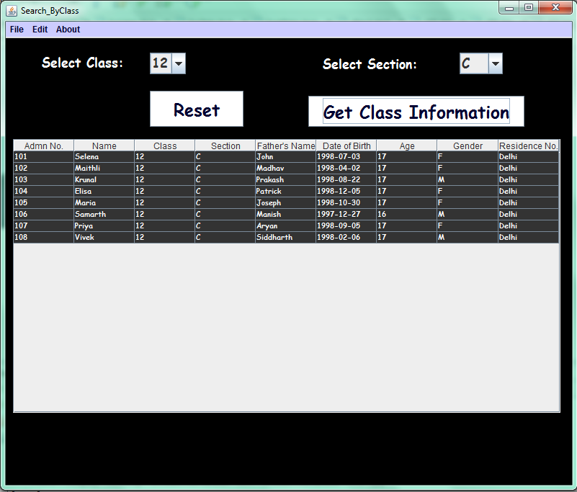

import java.sql.Connection;

import java.sql.DriverManager;

import java.sql.ResultSet;

import javax.swing.table.DefaultTableModel;

public class byclass extends javax.swing.JFrame {

public byclass()

{

initComponents();

setTitle("Search_ByClass");

}

**// Code for Get Class Information**

private void jButton3ActionPerformed(java.awt.event.ActionEvent evt) {

DefaultTableModel model=(DefaultTableModel) jTable1.getModel();

String a=(String) c.getSelectedItem();

String b=(String) s.getSelectedItem();

try

{

Class.forName("java.sql.DriverManager");

Connection con=DriverManager.getConnection("jdbc:mysql://localhost:3306/studentdatabase","root","admin");

java.sql.Statement stmt=con.createStatement();

String Query="Select * from info where clas="+a+"&& section='"+b+"';";

ResultSet rs = stmt.executeQuery(Query);

while(rs.next()){

String Admno=rs.getString("Admno");

String Name=rs.getString("Name");

String Class=rs.getString("Clas");

String Section=rs.getString("Section");

String Fname=rs.getString("Father");

String dob=rs.getString("date");

String Age=rs.getString("Age");

String Gender=rs.getString("Gender");

String Resno=rs.getString("Residency");

model.addRow(new Object[]{Admno,Name,Class,Section,Fname,dob,Age,Gender,Resno}); }

int rows=model.getRowCount();

if(rows>1)

{

for(int i=0;i<rows;i++)

model.removeRow(rows);

}

}

catch (Exception e)

{

System.out.println(e.getMessage());

}

}

**// Code for Reset Button**

private void jButton4ActionPerformed(java.awt.event.ActionEvent evt) {

c.setSelectedIndex(0);

s.setSelectedIndex(0);

DefaultTableModel model=(DefaultTableModel) jTable1.getModel();

int rows=model.getRowCount();

if (rows>0){

for(int i=0;i<rows;i++){

model.removeRow(0); }

}

}

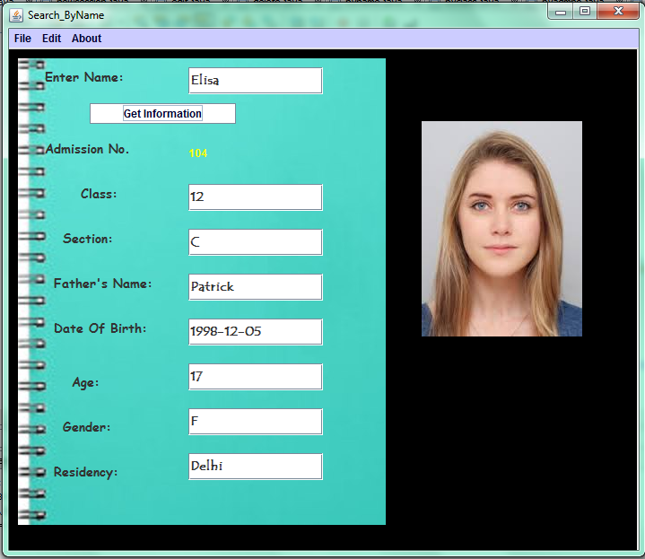

import java.sql.*;

import javax.swing.ImageIcon;

import javax.swing.JOptionPane;

public class byname extends javax.swing.JFrame {

public byname() {

initComponents();

setTitle("Search_ByName");

}

**//Code for Get Information Page**

private void jButton4ActionPerformed(java.awt.event.ActionEvent evt) {

String name = n3.getText();

String Path = "";

int admno,clas,age;

String section,date,fname,gender,resno;

try

{

Class.forName("java.sql.DriverManager");

Connection con = DriverManager.getConnection("jdbc:mysql://localhost:3306/studentdatabase", "root", "admin");

Statement stmt = con.createStatement();

String Query = "Select * from info where name='" + name + "';";

ResultSet rs = stmt.executeQuery(Query);

while (rs.next()) {

admno=Integer.parseInt(rs.getString("Admno"));

clas=Integer.parseInt(rs.getString("Clas"));

age=Integer.parseInt(rs.getString("Age"));

resno=rs.getString("Residency");

section=rs.getString("Section");

date=rs.getString("date");

fname=rs.getString("Father");

gender=rs.getString("Gender");

Path = rs.getString("Path");

jLabel4.setIcon(new ImageIcon(Path));

jLabel31.setText(""+admno);

c3.setText(""+clas);

s3.setText(section);

f3.setText(fname);

d3.setText(date);

a3.setText(""+age);

g3.setText(gender);

r3.setText(resno);

}

} catch (Exception e)

{

JOptionPane.showMessageDialog(this, e.getMessage());

}

}

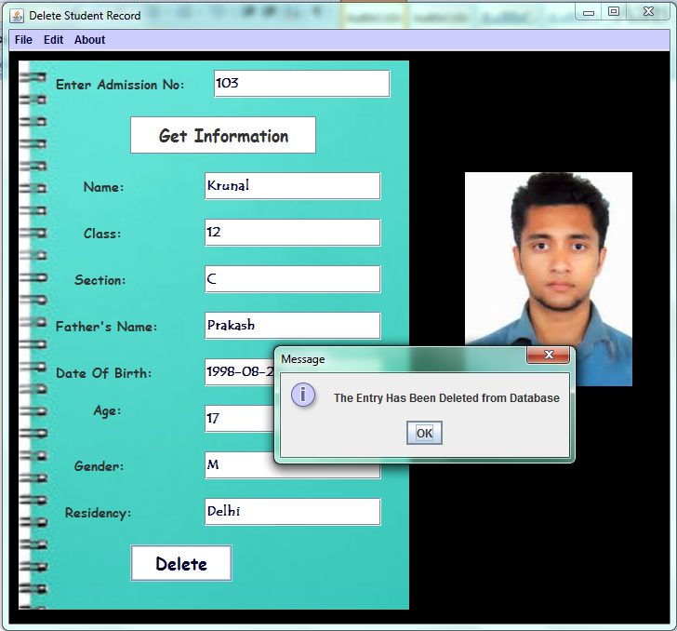

import java.sql.Connection;

import java.sql.DriverManager;

import java.sql.ResultSet;

import javax.swing.ImageIcon;

import javax.swing.JOptionPane;

public class delete extends javax.swing.JFrame {

public delete() {

initComponents();

setTitle("Delete Student Record"); }

**// Code for Get Information Button**

private void jButton3ActionPerformed(java.awt.event.ActionEvent evt) {

String Admno = adm.getText();

String Path = "";

int clas, age;

String section, date, fname, gender,name, resno;

try {

Class.forName("java.sql.DriverManager");

Connection con = DriverManager.getConnection("jdbc:mysql://localhost:3306/studentdatabase", "root", "admin");

java.sql.Statement stmt = con.createStatement();

String Query = "Select * from info where admno='" + Admno + "';";

ResultSet rs = stmt.executeQuery(Query);

while (rs.next()) {

name = rs.getString("name");

clas = Integer.parseInt(rs.getString("Clas"));

age = Integer.parseInt(rs.getString("Age"));

resno =rs.getString("Residency");

section = rs.getString("Section");

date = rs.getString("date");

fname = rs.getString("Father");

gender = rs.getString("Gender");

Path = rs.getString("Path");

System.out.println(Path);

jLabel3.setIcon(new ImageIcon(Path));

n2.setText(name);

c2.setText("" + clas);

s2.setText(section);

f2.setText(fname);

d2.setText(date);

a2.setText("" + age);

g2.setText(gender);

r2.setText(resno);

}

} catch (Exception e) {

JOptionPane.showMessageDialog(this, e.getMessage());

}

}

**//Code for Delete button**

private void jButton1ActionPerformed(java.awt.event.ActionEvent evt) {

int Admno = Integer.parseInt(adm.getText());

String Query = "";

int clas = Integer.parseInt(c2.getText());

String section = s2.getText();

String fname = f2.getText();

String date = d2.getText();

int age = Integer.parseInt(a2.getText());

String gender = g2.getText();

String Resno = r2.getText();

try {

Class.forName("java.sql.DriverManager");

Connection con = DriverManager.getConnection("jdbc:mysql://localhost:3306/studentdatabase", "root", "admin");

java.sql.Statement stmt = con.createStatement();

Query = "Delete from info where admno='" + Admno + "';";

int rs = stmt.executeUpdate(Query);

JOptionPane.showMessageDialog(this, "The Entry Has Been Deleted from Database");

adm.setText("");

n2.setText("");

c2.setText("");

s2.setText("");

f2.setText("");

d2.setText("");

a2.setText("");

g2.setText("");

r2.setText("");

jLabel3.setIcon(null);

} catch (Exception e) {

JOptionPane.showMessageDialog(this, e.getMessage());

} }

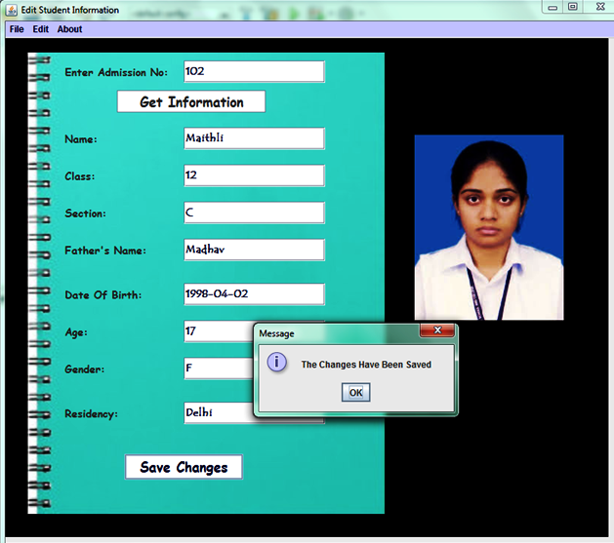

import java.sql.Connection;

import java.sql.DriverManager;

import java.sql.ResultSet;

import javax.swing.ImageIcon;

import javax.swing.JOptionPane;

public class edit extends javax.swing.JFrame {

public edit() {

initComponents();

setTitle("Edit Student Information");

}

**//Code for Get Information Button**

private void jButton3ActionPerformed(java.awt.event.ActionEvent evt) {

int Admno = Integer.parseInt(adm.getText());

String Path = "";

int clas, age;

String section, date, fname, gender,name, resno;

try {

Class.forName("java.sql.DriverManager");

Connection con = DriverManager.getConnection("jdbc:mysql://localhost:3306/studentdatabase", "root", "admin");

java.sql.Statement stmt = con.createStatement();

String Query = "Select * from info where admno='" + Admno + "';";

ResultSet rs = stmt.executeQuery(Query);

while (rs.next()) {

name = rs.getString("name");

clas = Integer.parseInt(rs.getString("Clas"));

age = Integer.parseInt(rs.getString("Age"));

resno = rs.getString("Residency");

section = rs.getString("Section");

date = rs.getString("date");

fname = rs.getString("Father");

gender = rs.getString("Gender");

Path = rs.getString("Path");

System.out.println(Path);

jLabel3.setIcon(new ImageIcon(Path));

n2.setText(name);

c2.setText("" + clas);

s2.setText(section);

f2.setText(fname);

d2.setText(date);

a2.setText("" + age);

g2.setText(gender);

r2.setText(resno);

}

} catch (Exception e) {

JOptionPane.showMessageDialog(this,e.getMessage());

}

}

**//Code for Save Changes Button**

private void jButton1ActionPerformed(java.awt.event.ActionEvent evt) {

int Admno = Integer.parseInt(adm.getText());

String Query = "";

int clas = Integer.parseInt(c2.getText());

String section = s2.getText();

String fname = f2.getText();

String date = d2.getText();

int age = Integer.parseInt(a2.getText());

String gender = g2.getText();

String Resno =r2.getText();

try {

Class.forName("java.sql.DriverManager");

Connection con = DriverManager.getConnection("jdbc:mysql://localhost:3306/studentdatabase", "root", "admin");

java.sql.Statement stmt = con.createStatement();

Query = "Update info set clas=" + clas + ",section='" + section + "',father='" + fname + "',date='" + date + "',age=" + age + ",gender='" + gender + "',residency='" + Resno + "' where admno=" + Admno + " ;";

int rs = stmt.executeUpdate(Query);

JOptionPane.showMessageDialog(this,"The Changes Have Been Saved");

} catch (Exception e) {

JOptionPane.showMessageDialog(this, e.getMessage());

}

}

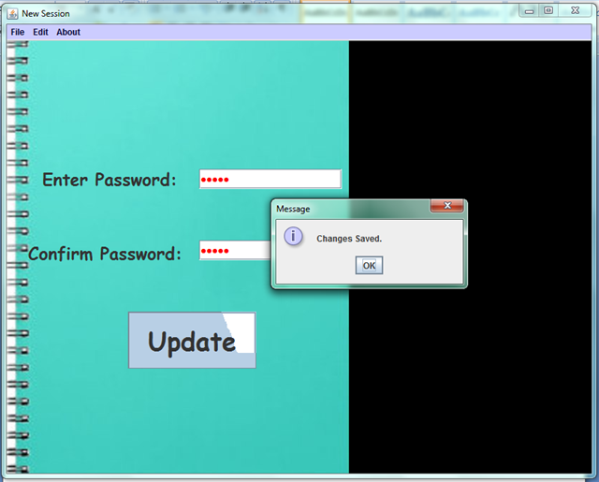

import java.sql.Connection;

import java.sql.DriverManager;

import javax.swing.JOptionPane;

public class newsession extends javax.swing.JFrame {

public newsession() {

initComponents();

setTitle("New Session");

}

**//Code for Update Button**

private void jButton4ActionPerformed(java.awt.event.ActionEvent evt) {

String Pass= new String(jPasswordField1.getPassword());

String Conf=new String(jPasswordField2.getPassword());

if(Pass.equals("admin") && Conf.equals("admin")){

String Query="";

String Update="";

try {

Class.forName("java.sql.DriverManager");

Connection con = DriverManager.getConnection("jdbc:mysql://localhost:3306/studentdatabase", "root", "admin");

java.sql.Statement stmt = con.createStatement();

Update = "Delete from info where clas=12;";

int rs = stmt.executeUpdate(Update);

} catch (Exception e) {

JOptionPane.showMessageDialog(this, e.getMessage());

}

try {

Class.forName("java.sql.DriverManager");

Connection con = DriverManager.getConnection("jdbc:mysql://localhost:3306/studentdatabase", "root", "admin");

java.sql.Statement stmt = con.createStatement();

Query = "Update info set clas=clas+1,age=age+1;";

int rs = stmt.executeUpdate(Query);

JOptionPane.showMessageDialog(this,"Changes Saved.");

}

catch (Exception e) {

JOptionPane.showMessageDialog(this, e.getMessage());

}}

else {

JOptionPane.showMessageDialog(this,"Enter Correct Password");

} }